Composite Solids with Flat and Cylindrical Surfaces

Definition
# Source: AI Source: Provided by: [Data Path: Persons Table -> ID Column: 1, Name_En Column: Motasem Essam] -> From: [ChatGPT] on [7/25/2026]
Composite Solids with Flat and Cylindrical Surfaces are three-dimensional geometric solids formed by combining two or more solid components whose external boundaries include both flat surfaces and cylindrical curved surfaces.
These composite solids contain planar faces, such as rectangles, squares, or circles, together with cylindrical curved surfaces. They may be formed by joining cylinders with prisms, cubes, other cylinders, or different solid shapes.
The combination can produce a solid with flat bases, flat side faces, circular faces, and one or more curved cylindrical surfaces.

Simple Definition
# Source: AI Source: Provided by: [Data Path: Persons Table -> ID Column: 1, Name_En Column: Motasem Essam] -> From: [ChatGPT] on [7/25/2026]
A composite solid with flat and cylindrical surfaces is a 3D shape that combines flat faces and cylindrical curved surfaces.

Geometric Representation
# Source: AI Source: Provided by: [Data Path: Persons Table -> ID Column: 1, Name_En Column: Motasem Essam] -> From: [ChatGPT] on [7/25/2026]
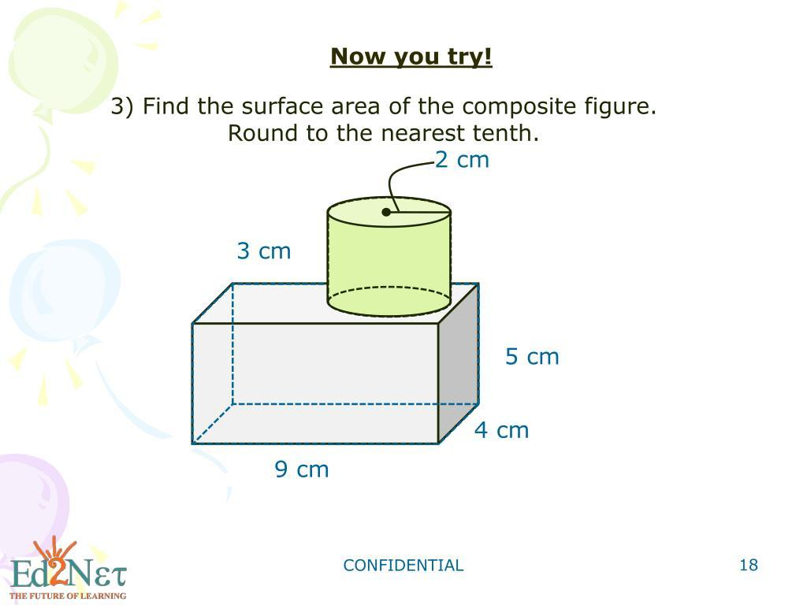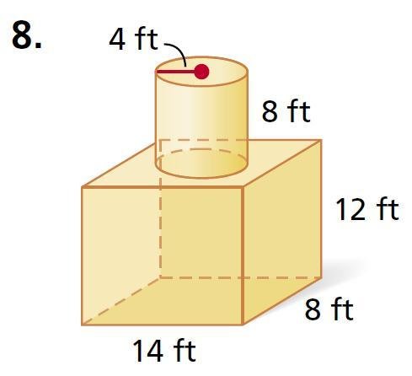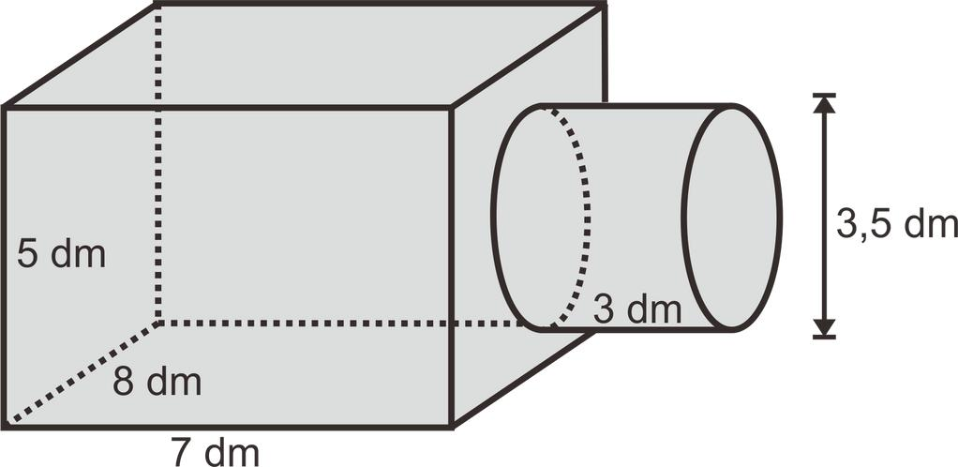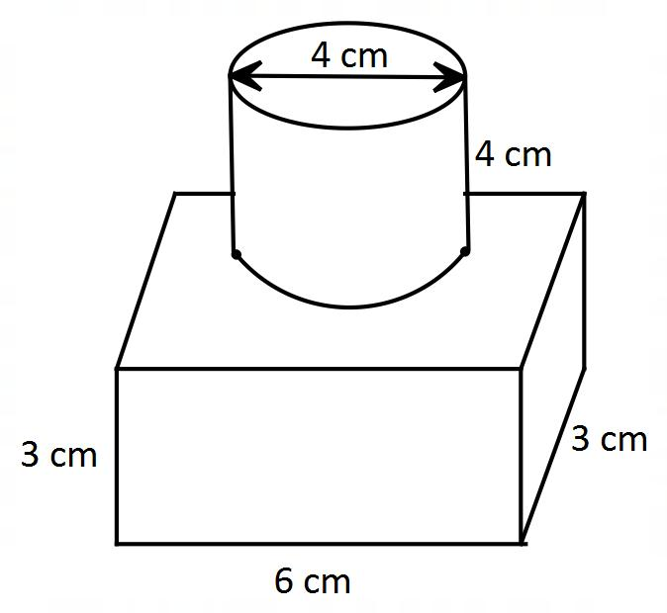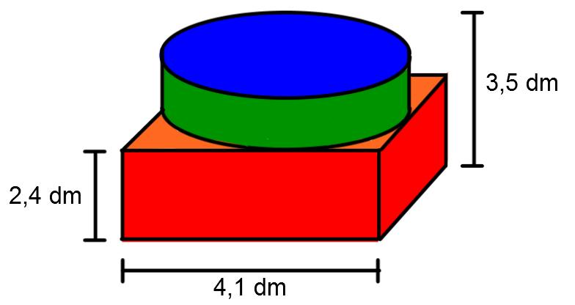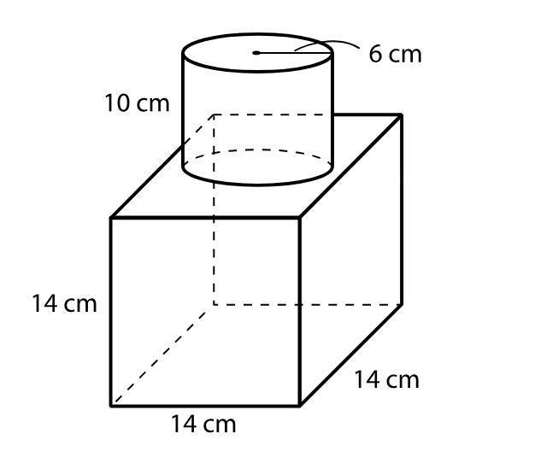
The main surface types are:
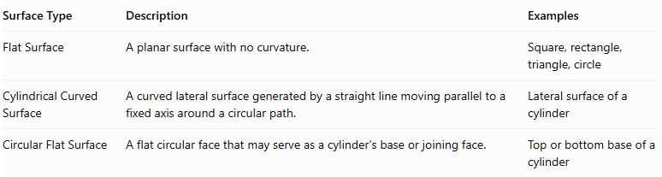
Surface Type | Description | Examples
Flat Surface | A planar surface with no curvature. | Square, rectangle, triangle, circle
Cylindrical Curved Surface | A curved lateral surface generated by a straight line moving parallel to a fixed axis around a circular path. | Lateral surface of a cylinder
Circular Flat Surface | A flat circular face that may serve as a cylinder's base or joining face. | Top or bottom base of a cylinder
Important: A cylinder has two flat circular bases and one curved lateral surface. Therefore, a composite solid containing cylinders may have both flat and cylindrical curved surfaces.

Main Classification
# Source: AI Source: Provided by: [Data Path: Persons Table -> ID Column: 1, Name_En Column: Motasem Essam] -> From: [ChatGPT] on [7/25/2026]
Composite solids with flat and cylindrical surfaces can be classified according to the arrangement and combination of their component solids.

Prism-Based Composite Solids
# Source: AI Source: Provided by: [Data Path: Persons Table -> ID Column: 1, Name_En Column: Motasem Essam] -> From: [ChatGPT] on [7/25/2026]
A prism-based composite solid combines one or more prisms with cylinders or cylindrical components.
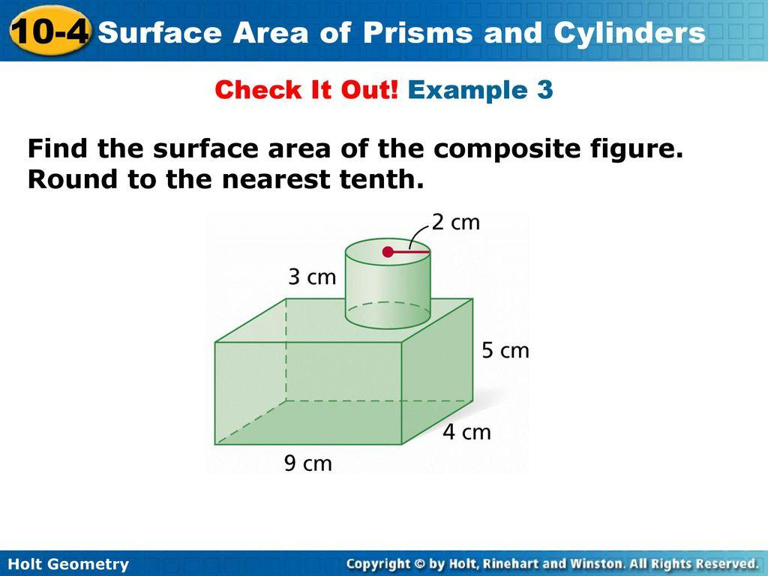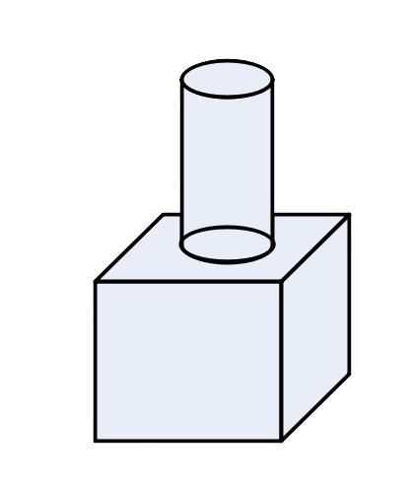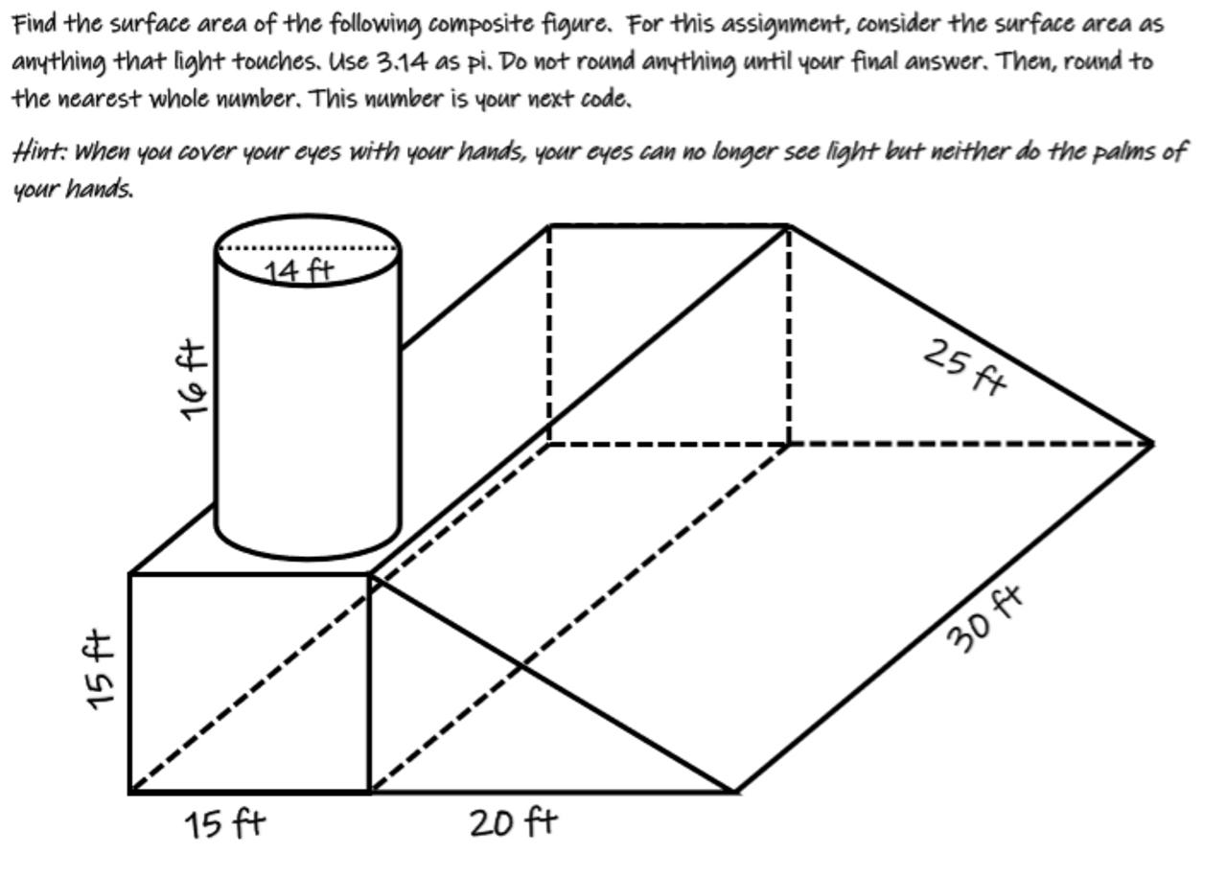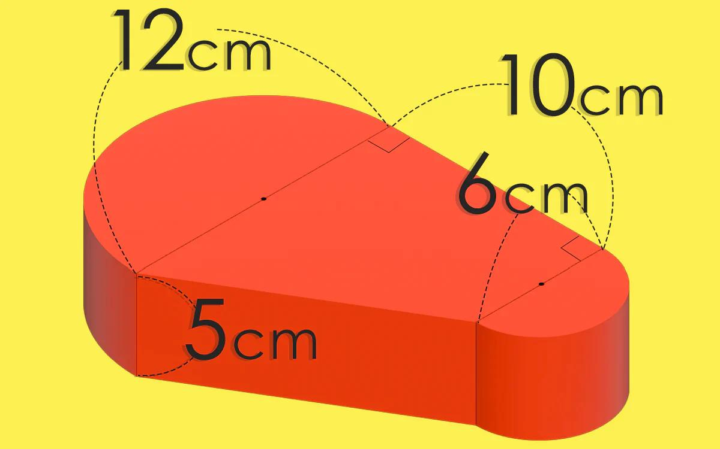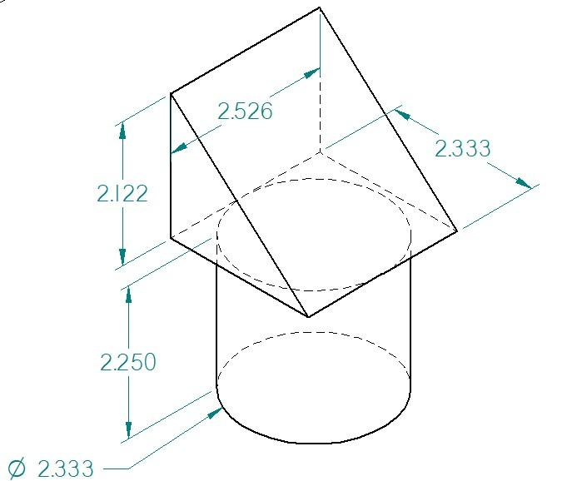
Examples:
- Rectangular Prism with a Cylinder
- Cube with a Cylinder
- Triangular Prism with a Cylinder
- Polygonal Prism with a Cylinder
- Multiple Prisms with Cylindrical Components

Cylinder-Based Composite Solids
# Source: AI Source: Provided by: [Data Path: Persons Table -> ID Column: 1, Name_En Column: Motasem Essam] -> From: [ChatGPT] on [7/25/2026]
A cylinder-based composite solid combines two or more cylindrical components, potentially with different dimensions or orientations.
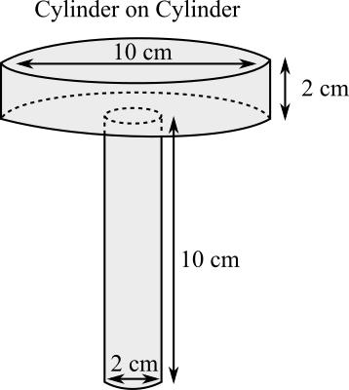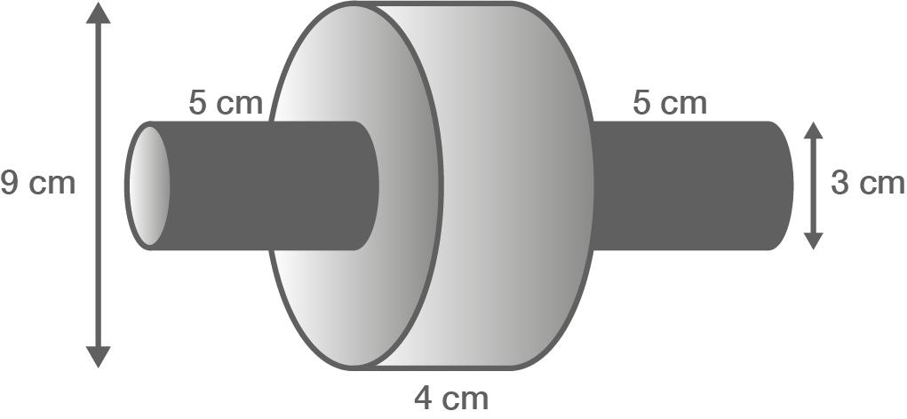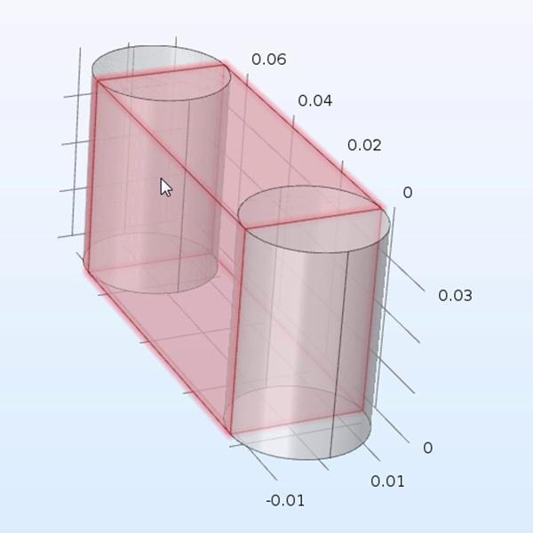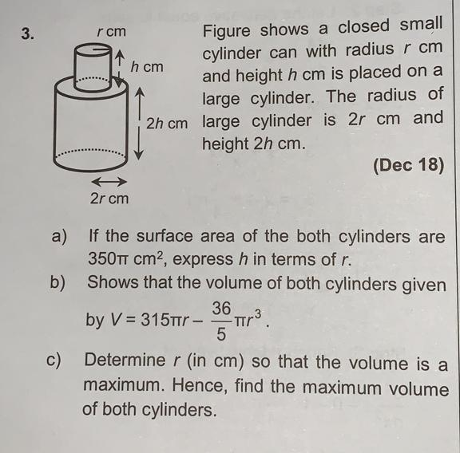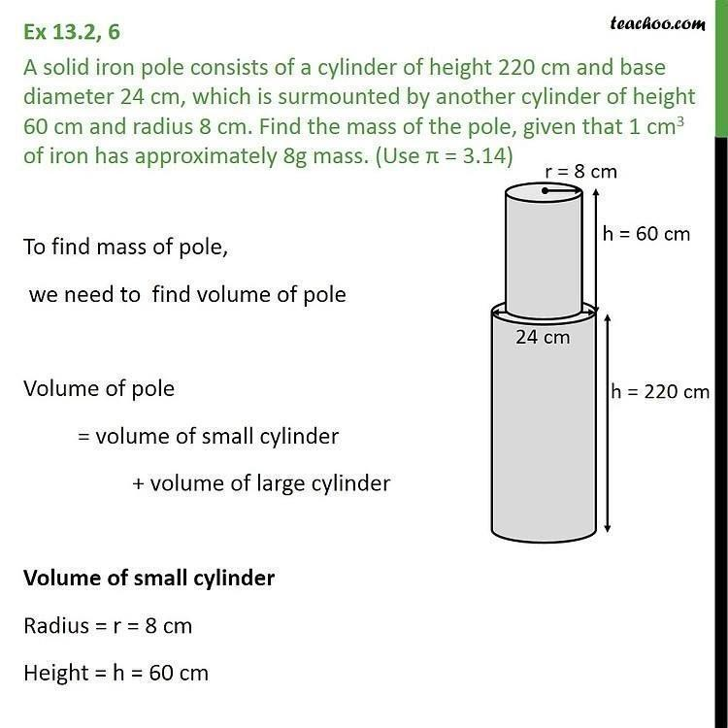
Examples:
- Two Cylinders Joined End-to-End
- Coaxial Cylinders with Different Radii
- Perpendicular Cylinders
- Parallel Cylinders
- Cylinder with Multiple Cylindrical Extensions

Mixed-Shape Composite Solids
# Source: AI Source: Provided by: [Data Path: Persons Table -> ID Column: 1, Name_En Column: Motasem Essam] -> From: [ChatGPT] on [7/25/2026]
A mixed-shape composite solid combines cylindrical components with different types of flat-faced solids.
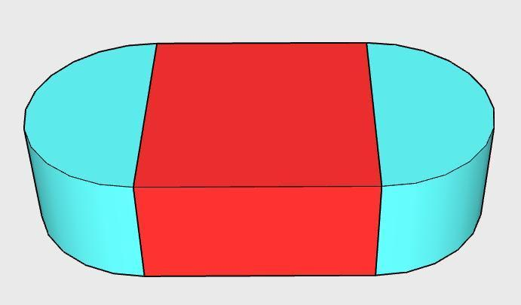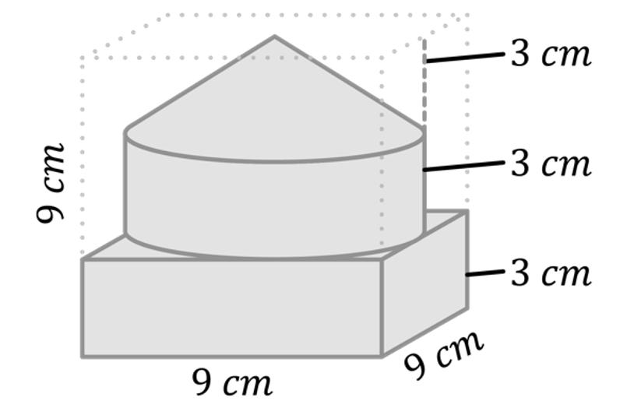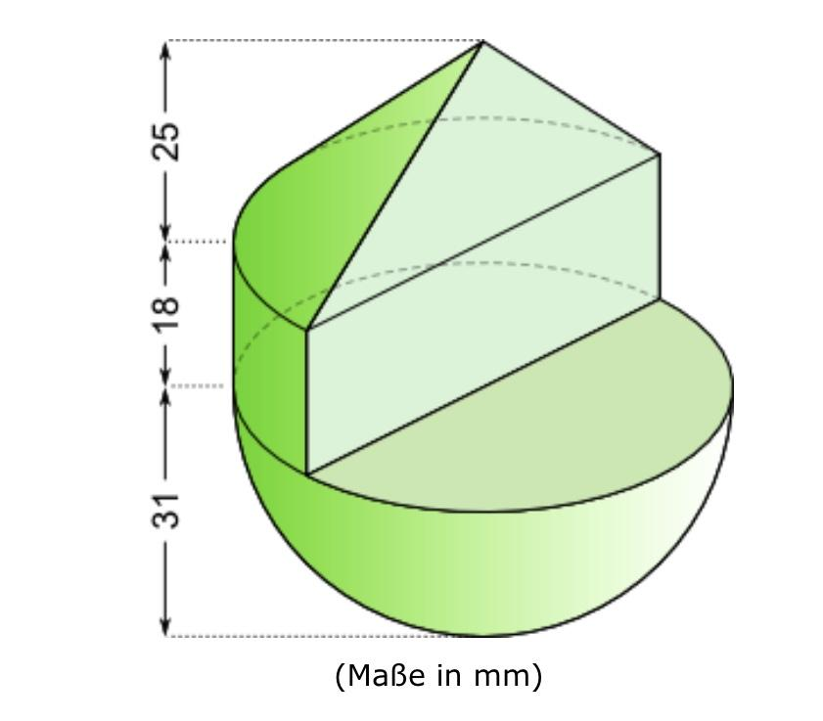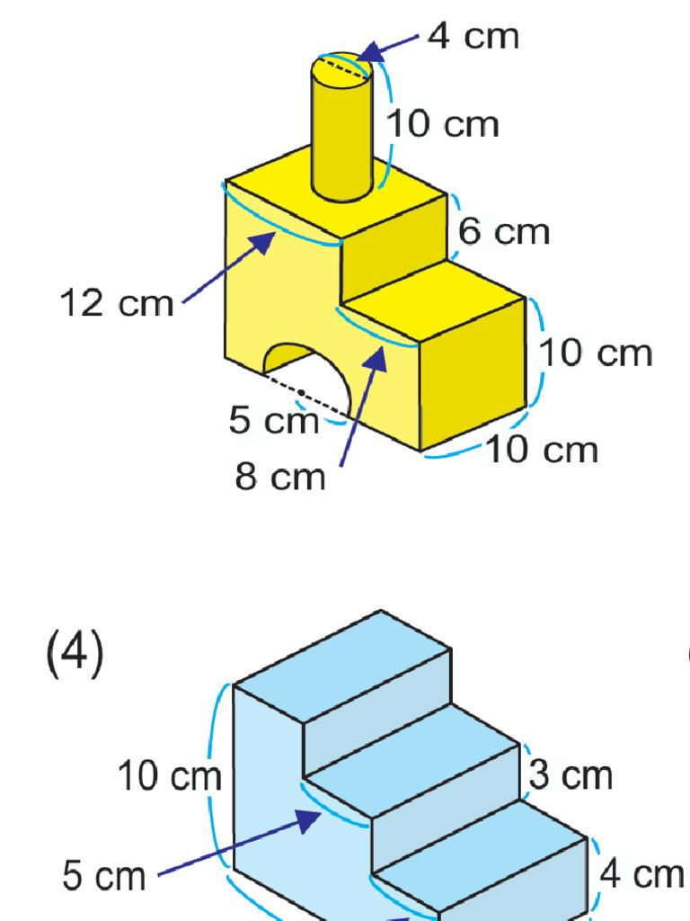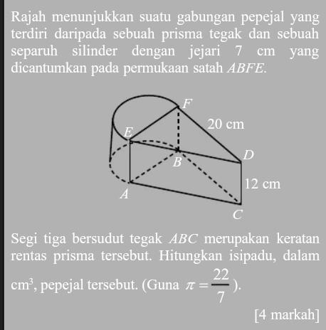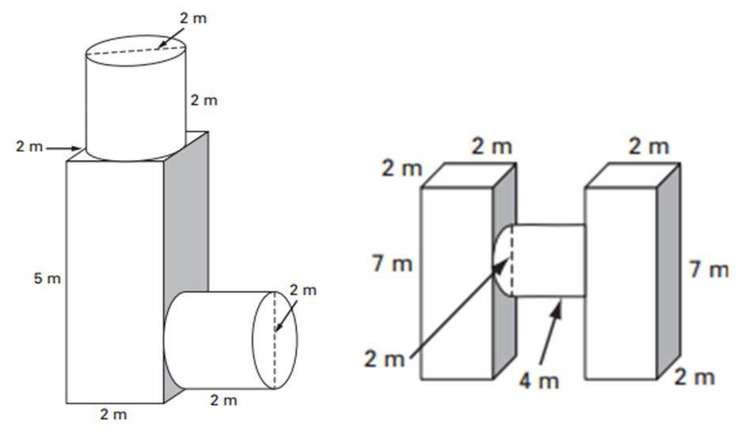
Examples:
- Cylinder with a Rectangular Prism and a Cube
- Cylinder with a Triangular Prism
- Cylinder with a Pyramid and a Prism
- Multiple Cylinders with Different Prisms
- Complex Mixed-Shape Composite Solids

Classification by Surface Arrangement
# Source: AI Source: Provided by: [Data Path: Persons Table -> ID Column: 1, Name_En Column: Motasem Essam] -> From: [ChatGPT] on [7/25/2026]
The external surfaces can also be classified according to how the flat and cylindrical surfaces are arranged.
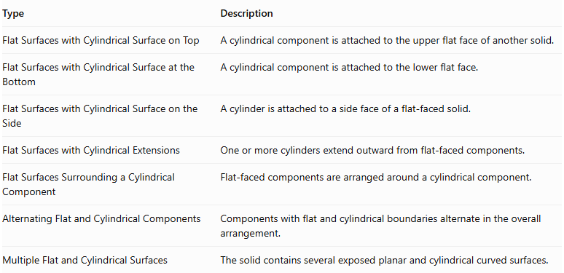
Type | Description
Flat Surfaces with Cylindrical Surface on Top | A cylindrical component is attached to the upper flat face of another solid.
Flat Surfaces with Cylindrical Surface at the Bottom | A cylindrical component is attached to the lower flat face.
Flat Surfaces with Cylindrical Surface on the Side | A cylinder is attached to a side face of a flat-faced solid.
Flat Surfaces with Cylindrical Extensions | One or more cylinders extend outward from flat-faced components.
Flat Surfaces Surrounding a Cylindrical Component | Flat-faced components are arranged around a cylindrical component.
Alternating Flat and Cylindrical Components | Components with flat and cylindrical boundaries alternate in the overall arrangement.
Multiple Flat and Cylindrical Surfaces | The solid contains several exposed planar and cylindrical curved surfaces.

Classification by Component Arrangement
# Source: AI Source: Provided by: [Data Path: Persons Table -> ID Column: 1, Name_En Column: Motasem Essam] -> From: [ChatGPT] on [7/25/2026]
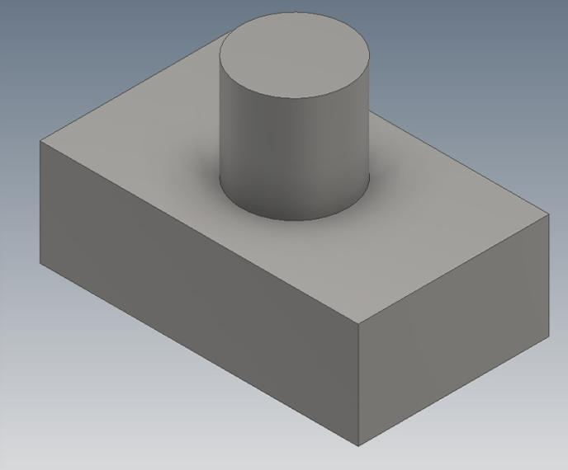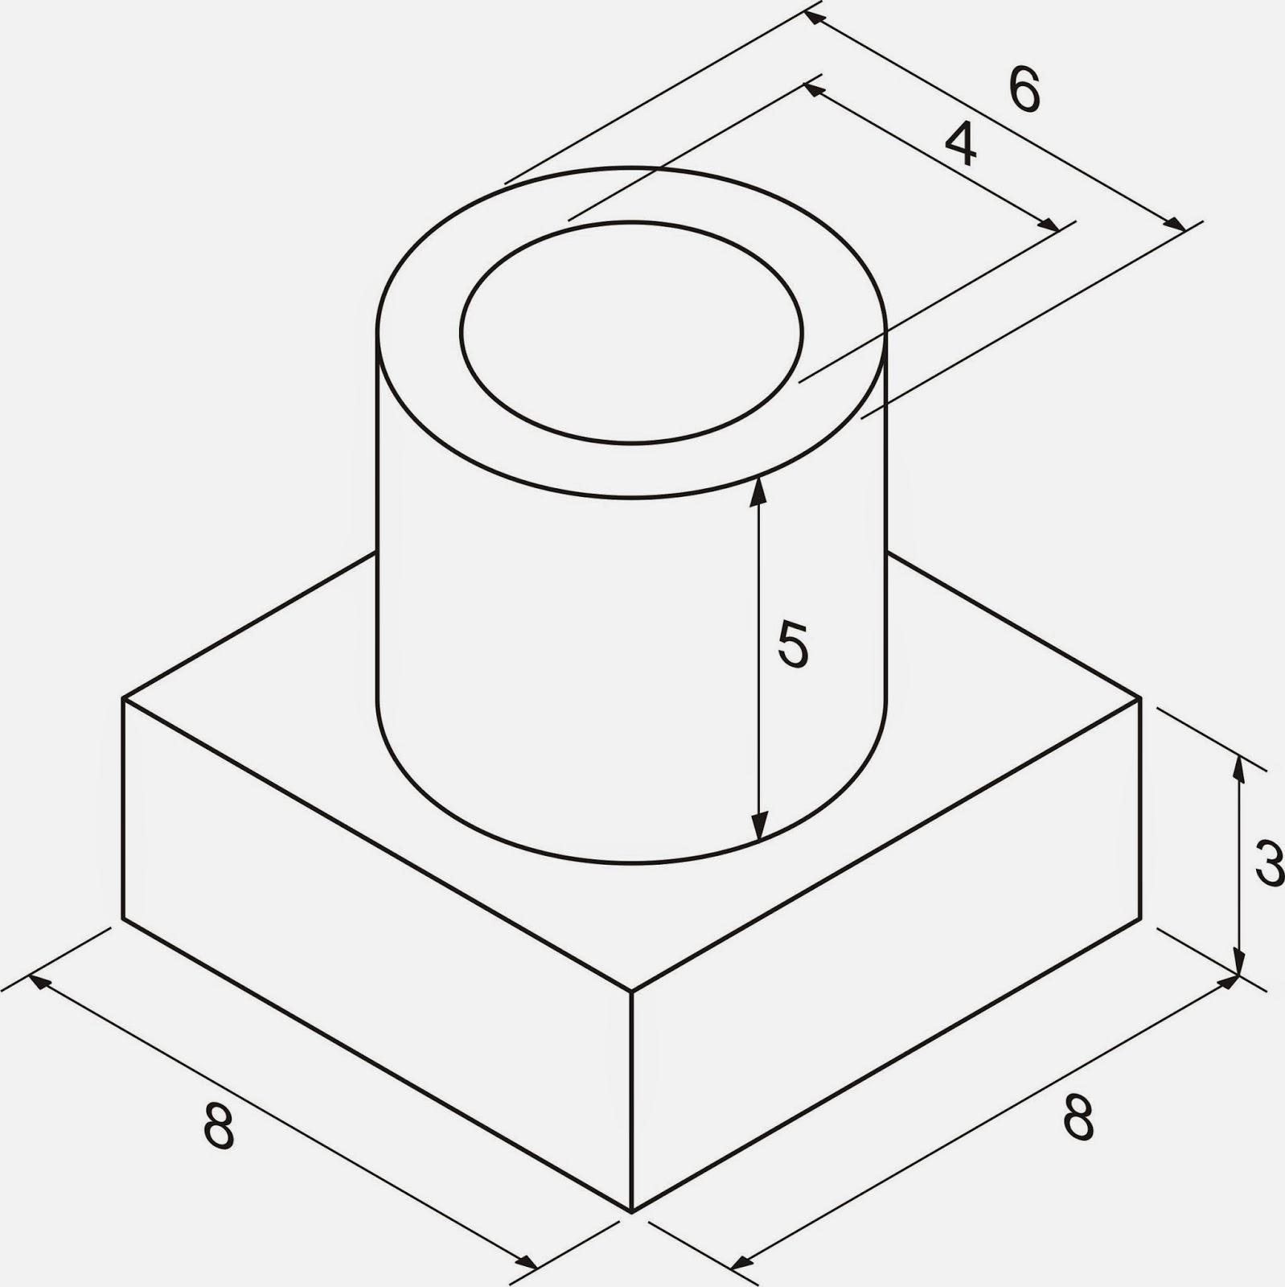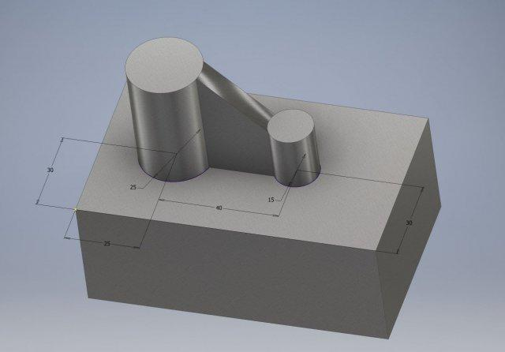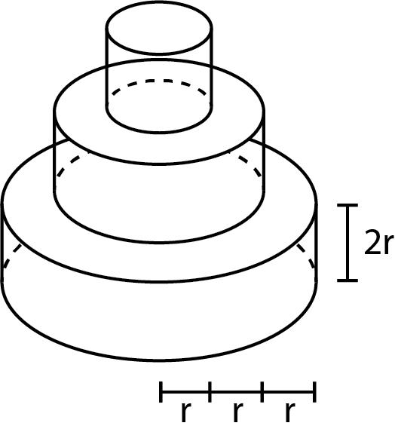
- Stacked Arrangement: Cylindrical and flat-faced components are placed above or below one another.
- End-to-End Arrangement: Components are connected consecutively along a common direction.
- Side-Attached Arrangement: Cylindrical components are connected to the side faces of flat-faced components.
- Coaxial Arrangement: Cylinders share the same central axis, possibly with different radii.
- Perpendicular Arrangement: Cylindrical and flat-faced components are joined at perpendicular orientations.
- Multi-Directional Arrangement: Components extend in several different directions from a central component.

Mathematical Properties and Formulas
# Source: AI Source: Provided by: [Data Path: Persons Table -> ID Column: 1, Name_En Column: Motasem Essam] -> From: [ChatGPT] on [7/25/2026]
The volume and surface area depend on the dimensions, shapes, and joining arrangement of the component solids.

Volume
# Source: AI Source: Provided by: [Data Path: Persons Table -> ID Column: 1, Name_En Column: Motasem Essam] -> From: [ChatGPT] on [7/25/2026]
For components that are joined without overlapping interiors:
$$V_{total}=\sum_{i=1}^{n}{V_{i}}$$
For a composite solid containing a rectangular prism and a cylinder:
$$V_{total}=V_{prism}+V_{cylinder}$$
Rectangular prism:
$$V_{prism}=lwh$$
Cylinder:
$$V_{cylinder}=πr^{2}h$$
Therefore:
$$\boxed{V_{total}=lwh+πr^{2}h_{c}}$$
Where:
- $l$ = length of the rectangular prism.
- $w$ = width of the rectangular prism.
- $h$ = height of the rectangular prism.
- $r$ = radius of the cylinder.
- $h_{c}$ = height or length of the cylindrical component.

Surface Area
# Source: AI Source: Provided by: [Data Path: Persons Table -> ID Column: 1, Name_En Column: Motasem Essam] -> From: [ChatGPT] on [7/25/2026]
The external surface area is the sum of all exposed surfaces. Surfaces hidden where components join must be excluded.
For two components joined through matching complete planar faces:
$${SA}_{total}={SA}_{1}+{SA}_{2}-2A_{joining}$$
For a rectangular prism:
$${SA}_{prism}=2(lw+lh+wh)$$
For a cylinder:
$${SA}_{cylinder}=2πr^{2}+2π{rh}_{c}$$
If a cylinder is attached to a rectangular prism through a circular region completely contained within one flat face, the joining region has area $πr^{2}$. Thus:
$${SA}_{total}={SA}_{prism}+{SA}_{cylinder}-2πr^{2}$$
Simplifying:
$$\boxed{{SA}_{total}={SA}_{prism}+2π{rh}_{c}}$$
This formula assumes the cylinder's circular base is fully hidden by the joining face and that no other surfaces overlap.

Worked Examples

Example 1: Rectangular Prism with a Vertical Cylinder on Top
# Source: AI Source: Provided by: [Data Path: Persons Table -> ID Column: 1, Name_En Column: Motasem Essam] -> From: [ChatGPT] on [7/25/2026]
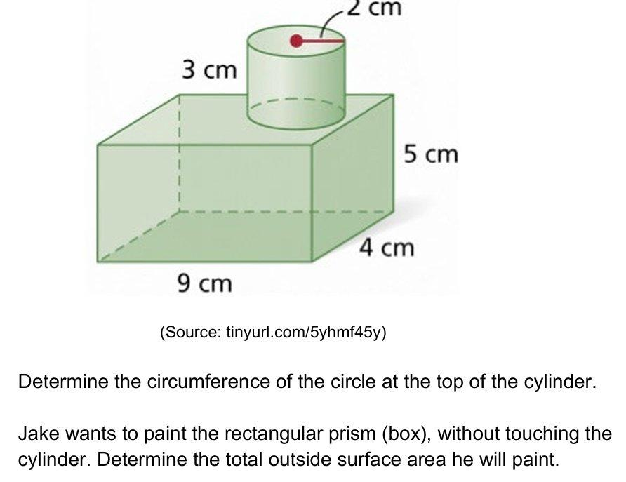
Given:
- Rectangular prism: $10×8×6$ cm.
- Cylinder radius: $2$ cm.
- Cylinder height: $5$ cm.
- The cylinder is attached to the top face, with its circular base completely inside that face.
Step 1: Calculate the rectangular prism volume.
$$V_{p}=10×8×6=480$$
Step 2: Calculate the cylinder volume.
$$V_{c}=π(2)^{2}(5)=20π$$
Step 3: Calculate total volume.
$$V=480+20π$$
$$\boxed{V≈542.83{ cm}^{3}}$$
Step 4: Calculate the rectangular prism surface area.
$${SA}_{p}=2(10×8+10×6+8×6)$$
$${SA}_{p}=376{ cm}^{2}$$
Step 5: Calculate the cylinder surface area.
$${SA}_{c}=2π(2)^{2}+2π(2)(5)$$
$${SA}_{c}=28π$$
Step 6: Calculate the exposed external surface area.
$$SA=376+28π-2π(2)^{2}$$
$$SA=376+20π$$
$$\boxed{SA≈438.83{ cm}^{2}}$$

Example 2: Two Coaxial Cylinders Attached to a Rectangular Prism
# Source: AI Source: Provided by: [Data Path: Persons Table -> ID Column: 1, Name_En Column: Motasem Essam] -> From: [ChatGPT] on [7/25/2026]
Given:
- Rectangular prism: $12×8×6$ cm.
- First cylinder: radius $2$ cm, length $4$ cm.
- Second cylinder: radius $2$ cm, length $3$ cm.
- Both cylinders are joined end-to-end, with the first cylinder attached to a rectangular face of the prism.
- Both joining faces are completely hidden.
Step 1: Calculate the rectangular prism volume.
$$V_{p}=12×8×6=576$$
Step 2: Calculate the first cylinder volume.
$$V_{1}=π(2)^{2}(4)=16π$$
Step 3: Calculate the second cylinder volume.
$$V_{2}=π(2)^{2}(3)=12π$$
Step 4: Calculate total volume.
$$V=576+16π+12π$$
$$\boxed{V≈663.96{ cm}^{3}}$$
Step 5: Calculate the rectangular prism surface area.
$${SA}_{p}=2(12×8+12×6+8×6)$$
$${SA}_{p}=432{ cm}^{2}$$
Step 6: Calculate the exposed cylindrical surfaces.
The combined exposed curved lateral area is:
$${SA}_{c}=2π(2)(4)+2π(2)(3)$$
$${SA}_{c}=28π$$
The two joining circular faces are hidden. The exposed outer circular end face remains visible.
Step 7: Calculate total external surface area.
$$SA=432+28π$$
$$\boxed{SA≈519.96{ cm}^{2}}$$

Important Characteristics
# Source: AI Source: Provided by: [Data Path: Persons Table -> ID Column: 1, Name_En Column: Motasem Essam] -> From: [ChatGPT] on [7/25/2026]
- Mixed Surface Geometry: The solid contains both planar and cylindrical curved surfaces.
- Multiple Components: It is constructed from two or more geometric solids.
- Flat Joining Faces: Components may connect through planar faces or partial planar contact regions.
- Curved Lateral Surfaces: Cylindrical components contribute curved external surfaces.
- Variable Arrangements: Components can be stacked, attached, aligned, or arranged in different directions.
- Volume Calculation: Component volumes can be added when their interiors do not overlap.
- Surface Area Calculation: Only exposed external surfaces are included in the external surface area.
- Different Dimensions: Components may have different radii, lengths, heights, and base dimensions.

Comparison with Other Surface Combinations
# Source: AI Source: Provided by: [Data Path: Persons Table -> ID Column: 1, Name_En Column: Motasem Essam] -> From: [ChatGPT] on [7/25/2026]
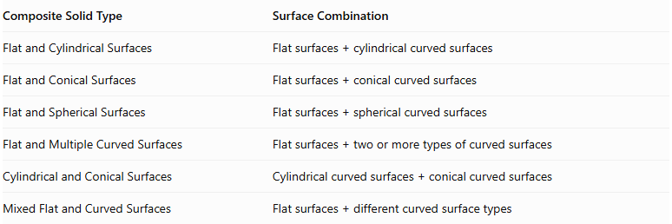
Composite Solid Type | Surface Combination
Flat and Cylindrical Surfaces | $$Flatsurfaces+cylindricalcurvedsurfaces$$
Flat and Conical Surfaces | $$Flatsurfaces+conicalcurvedsurfaces$$
Flat and Spherical Surfaces | $$Flatsurfaces+sphericalcurvedsurfaces$$
Flat and Multiple Curved Surfaces | $$Flatsurfaces+twoormoretypesofcurvedsurfaces$$
Cylindrical and Conical Surfaces | $$Cylindricalcurvedsurfaces+conicalcurvedsurfaces$$
Mixed Flat and Curved Surfaces | $$Flatsurfaces+differentcurvedsurfacetypes$$

Applications
# Source: AI Source: Provided by: [Data Path: Persons Table -> ID Column: 1, Name_En Column: Motasem Essam] -> From: [ChatGPT] on [7/25/2026]
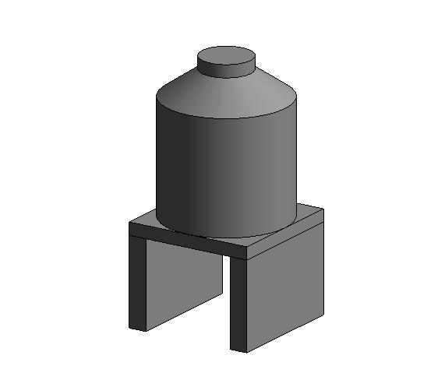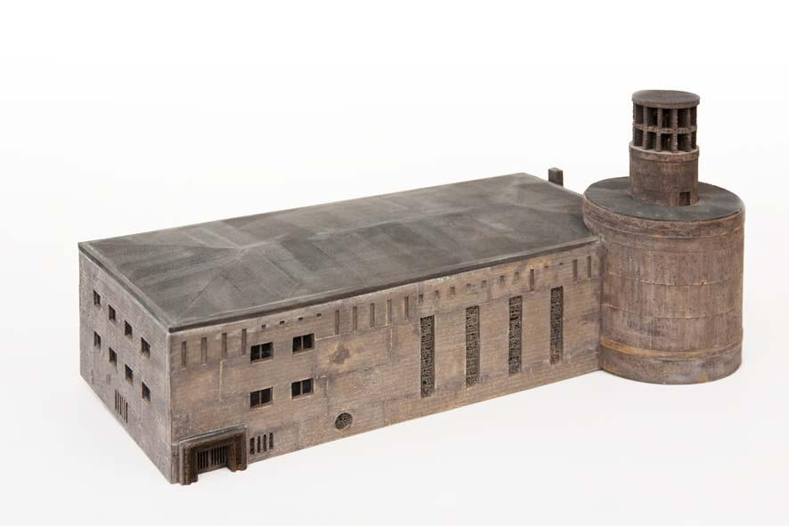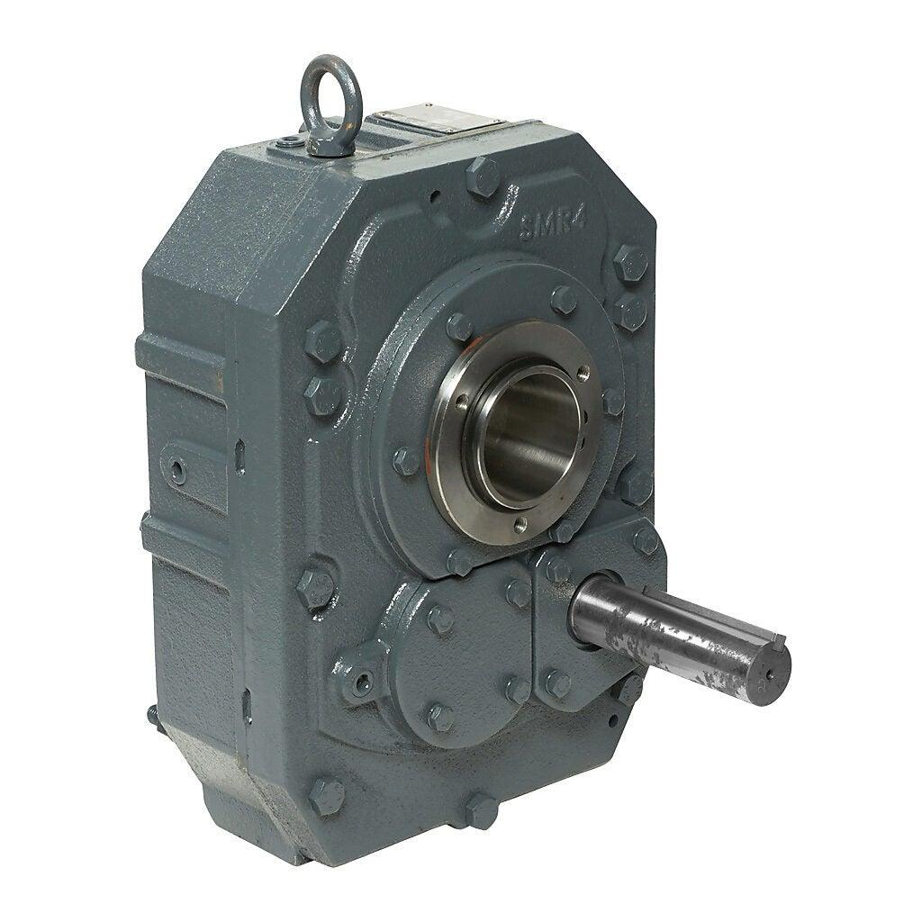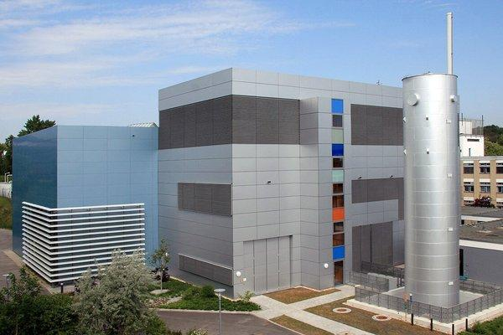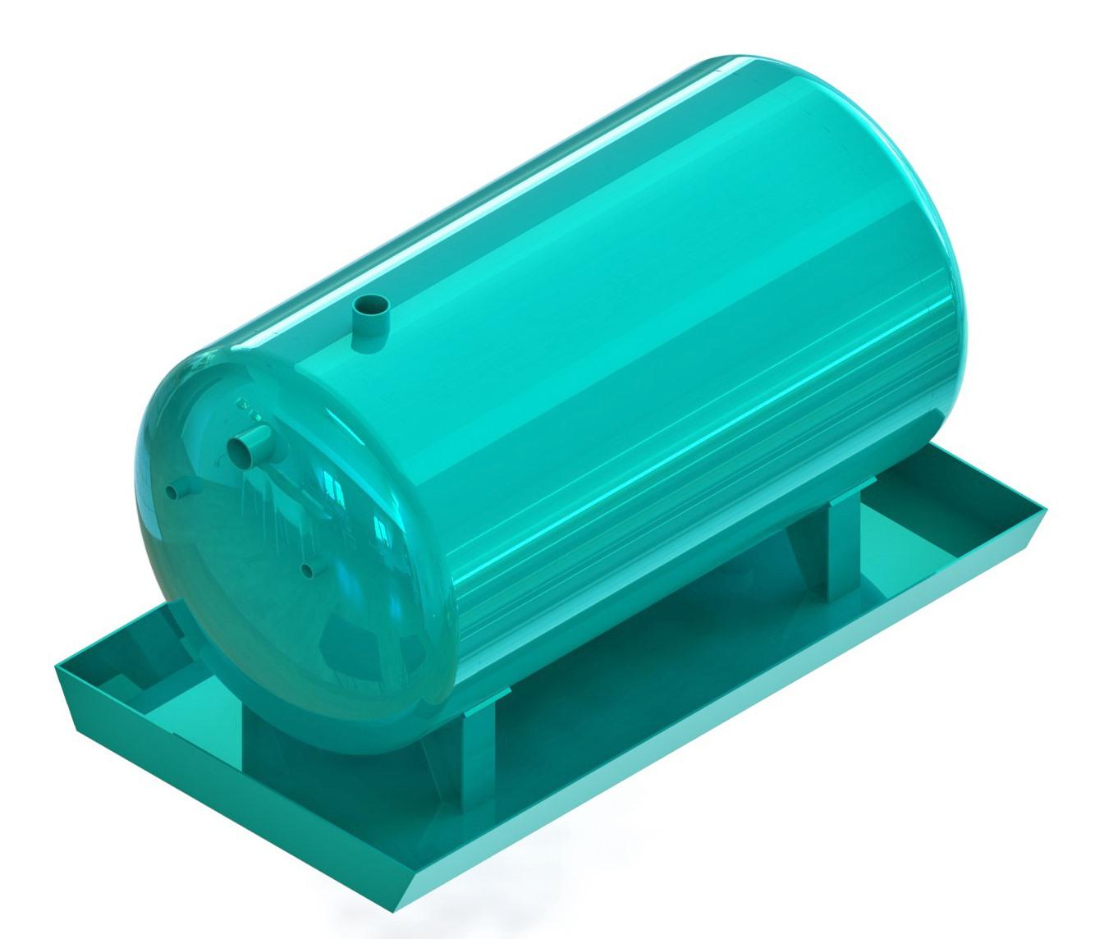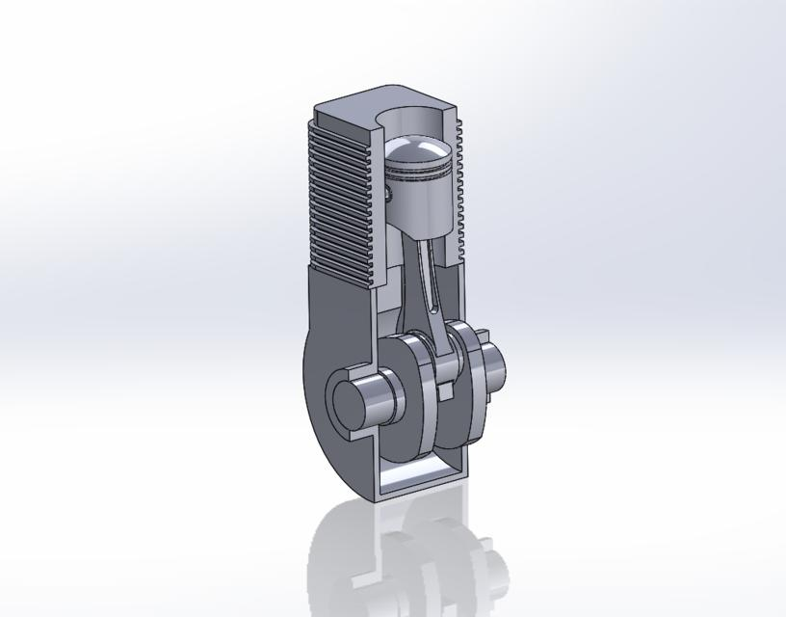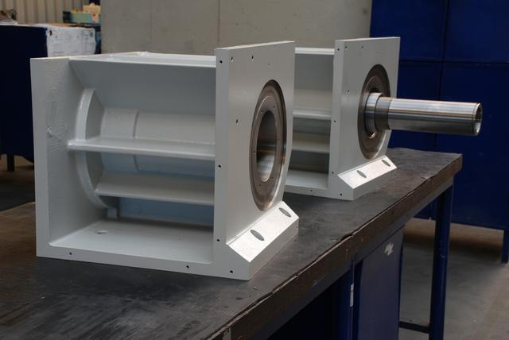
- Mechanical Engineering: Shafts, housings, cylindrical extensions, and mechanical assemblies.
- Architecture: Buildings combining rectangular structures and cylindrical towers.
- Storage Systems: Tanks and containers mounted on flat structural bases.
- Industrial Equipment: Cylindrical pipes and components connected to rectangular housings.
- Product Design: Objects combining flat supporting structures with cylindrical parts.

Key Points
# Source: AI Source: Provided by: [Data Path: Persons Table -> ID Column: 1, Name_En Column: Motasem Essam] -> From: [ChatGPT] on [7/25/2026]
- Composite solids with flat and cylindrical surfaces combine planar faces with cylindrical curved surfaces.
- They can be formed from prisms, cubes, cylinders, and mixed geometric components.
- Their arrangements include stacked, end-to-end, side-attached, coaxial, and perpendicular configurations.
- Total volume is calculated by combining component volumes while avoiding double-counting.
- External surface area includes only exposed surfaces.
- Hidden joining regions must be excluded from surface-area calculations.

Conclusion
# Source: AI Source: Provided by: [Data Path: Persons Table -> ID Column: 1, Name_En Column: Motasem Essam] -> From: [ChatGPT] on [7/25/2026]
Composite Solids with Flat and Cylindrical Surfaces are three-dimensional geometric structures that combine flat-faced components with cylindrical components. They can have many different arrangements and dimensions, making them useful for studying complex geometric structures.
Their mathematical analysis depends on correctly calculating the total volume and identifying all exposed surfaces while excluding hidden joining regions.

